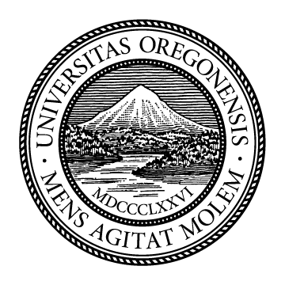

UNIVERSITY OF OREGON
Commencement
MONDAY, JUNE 15, 2026

Congratulations, Graduates
Welcome to the University of Oregon’s 2026 commencement celebration. We are honored to share this important day with you—our graduates—and with your families and friends.
Congratulations on this wonderful accomplishment. This is a day of joy and celebration, a time of reflection on all you have achieved, and a moment of gratitude for the people who have supported you along the way.
Your University of Oregon degree represents years of focus, hard work, dedication, and scholarship. Your experiences and resilience will continue to transform your life in ways that you may not yet imagine. Your journey is also now part of the long legacy of this great university.
While the term “graduation” signifies the completion of an academic journey, today we intentionally celebrate “commencement” to mark the beginning of your next chapter. As the newest member of our family of alumni, you now represent University of Oregon graduates across the state, nation, and world. We are honored and proud to count you among UO alumni.
Congratulations, again, and go Ducks!
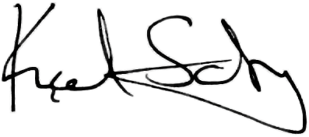
Karl Scholz
President

ORDER OF EXERCISES

Gra(n)d Entrance and Processional

Land Acknowledgment
Jason Younker
Associate Vice President and Advisor to the President on Sovereignty and Government-to-Government Relations

Posting of Colors
UO ROTC Honors Team

Welcome and Introduction of UO Chamber Choir
Christopher P. Long
Provost and Senior Vice President

National Anthem
UO Chamber Choir
Sharon Paul
Director of Choral Activities and Department Head of Music Performance

Greetings from the UO Board of Trustees
Steve Holwerda, MBA ’91
Board Chair

President’s Remarks
Karl Scholz
President

Student Remarks
Prissila Moreno
ASUO President 2025–26
David Mitrovčan Morgan
Student Trustee

Commencement Address
Marlee Matlin
Actress, advocate, and proud parent of a UO 2026 graduate

Conferral of Degrees
Karl Scholz
President
Christopher P. Long
Provost and Senior Vice President

EXECUTIVE LEADERSHIP

Karl Scholz
President
Christopher P. Long
Provost and Senior Vice President
Jamie Moffitt
Senior Vice President for Finance and Administration and Chief Financial Officer
Yvette Alex-Assensoh
Vice President for Equity and Inclusion
Joseph E. Buck
Vice President for Advancement
Angela Lauer Chong
Vice President for Student Life
Kassy Fisher
Chief of Staff and Senior Advisor to the President
Jane Gordon
Vice President for UO Portland

Robert Guldberg
Vice President and Robert and Leona DeArmond Executive Director of the Phil and Penny Knight Campus for Accelerating Scientific Impact
Carol Keese
Vice President for University Communications and Chief Marketing Officer
Kody Kelleher
University Secretary and Advisor to the President
Derek Kindle
Vice President for Enrollment Management
Rob Mullens
Director of Intercollegiate Athletics
Kevin Reed
Vice President and General Counsel
Geraldine Richmond
Interim Vice President for Research and Innovation

BOARD OF TRUSTEES
Steve Holwerda, MBA ’91
Board Chair
Marcia Aaron, BA ’86
Vice Chair
Cy Abbott
Graduate Student
Tim Boyle, BS ’71
Renée Evans Jackman, BA ’97
Elisa M. deCastro Hornecker, BA ’82
Renée James
Taliek Lopez-DuBoff
Student
David Mitrovčan Morgan
Student
Lillian Moses, BA ’09
Non-Faculty Staff
Gerard Sandoval
Faculty
Karl Scholz
Ex Officio
Connie Seeley, BS ’92
Andy Storment
Amy Tykeson
Jenny Ulum, MA ’83
Dennis Worden, BA ’06

CONGRATULATIONS, GRADUATES, FROM THE UO ALUMNI ASSOCIATION!
We are proud to welcome you to a community of Ducks over 270,000 strong, and we look forward to supporting you in all stages of flight. Wherever your journey takes you, we will be your lifelong connection to the university and to one another. Remember, “Once a Duck, always a Duck!”
To learn more about the UO Alumni Association, visit alumni.uoregon.edu

HONORING NATIVE PEOPLES AND LANDS
The University of Oregon is located on Kalapuya Ilihi, the traditional indigenous homeland of the Kalapuya people. Following treaties between 1851 and 1855, Kalapuya people were dispossessed of their indigenous homeland by the United States government and forcibly removed to the Coast Reservation in Western Oregon. Today, descendants are citizens of the Confederated Tribes of the Grand Ronde Community of Oregon and the Confederated Tribes of the Siletz Indians of Oregon, and continue to make important contributions in their communities, at UO, and across the land we now refer to as Oregon.
We express our respect for all federally recognized tribal nations of Oregon. This includes the Burns Paiute Tribe; the Confederated Tribes of the Coos, Lower Umpqua and Siuslaw Indians; the Confederated Tribes of the Grand Ronde Community of Oregon; the Confederated Tribes of Siletz Indians of Oregon; the Confederated Tribes of the Umatilla Indian Reservation; the Confederated Tribes of Warm Springs; the Coquille Indian Tribe; the Cow Creek Band of Umpqua Tribe of Indians; and the Klamath Tribes. We also express our respect for all other displaced Indigenous peoples who call Oregon home.
An equal-opportunity institution committed to cultural diversity and
compliance with the Americans with Disabilities Act. © 2026 University of Oregon


